PROJECT PROPOSAL

LED Light Bulb Project

PRESENTED TO
Dr. Cale Stolle
1014 Boswell Ave, Crete, NE, 68333

PRESENTED BY
THE DOANE ENGINEERING GROUP
HCDC
Henrique Henriques
Dillon Bailey
Caden Geiken
Caden Doolittle

CRETE, NE
12/10/2021
1. ABSTRACT
LED lamps gained space in the lighting market, both residential and commercial, due to their numerous advantages including low consumption of electric power when compared to common light bulbs and less time with maintenance since they have a longer lifespan. The quality delivered in this product starts with its manufacture, and guarantees maximum efficiency.To guarantee these advantages, the quality delivered in the final product goes through all stages, starting the design along with the manufacture of these models.We want to change the LED industry with a brand new state of the art, extremely effective, and efficient lightbulb. We effectively designed a preliminary prototype of an LED bulb that can lead to a production for the testing.

2. TABLE OF CONTENTS

ABSTRACT 1

TABLE OF CONTENTS 2

BACKGROUND AND SIGNIFICANCE 3

Electric circuit Background 3

Design Background 4

Standards Background 4

Manufacturing Background 5

PLAN OF ACTION 6

First Prototype 6

Electric Circuit 6

Design 6

Second Prototype 6

Electric Circuit 6

Design 6

Third Prototype 7

Electric Circuit 7

Design 7

Manufacturing Process 8

Project Timeline 12

ENGINEERING GROUP CAPABILITIES 12

Qualifications and Experience 12

Equipment and Facilities 13

PROPOSAL IMPACTS 13

Impacts to Client 13

Broader Impacts 14

Itemized Costs 14

REFERENCES 15

APPENDICES 15

3. BACKGROUND AND SIGNIFICANCE

3.1. Electric Circuits Background
When conducting our background research, we had to keep these things in mind: find the cheapest and most reliable product, find a product that requires little manufacturing time, and find a component that can fit inside of the lightbulb. There are many arguments when deciding between SMT or Through Hole circuit boards. From extensive research it was found that SMT boards were the most viable option for the lightbulb (5). This is due to through hole circuit boards taking longer to manufacture and cost more as the manufacturers have to drill holes through thicker board material. Also the thinner material in SMT circuit boards is not an issue as lightbulbs are not made to be sturdy (4). How they are attached to the board is shown by the figures below.

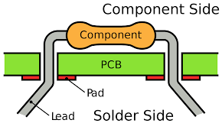[0.1]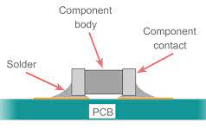[0.2]

When designing the circuit, the LED lights will be put in series as outlets have a high voltage low current and that allows series circuits to handle it better. To convert the AC power to DC, a bridge rectifier will need to be implemented. A bridge rectifier in essence is four diodes that converge the alternating current into a singular direction, thus converting the power. This is visualized by the figure below (3).

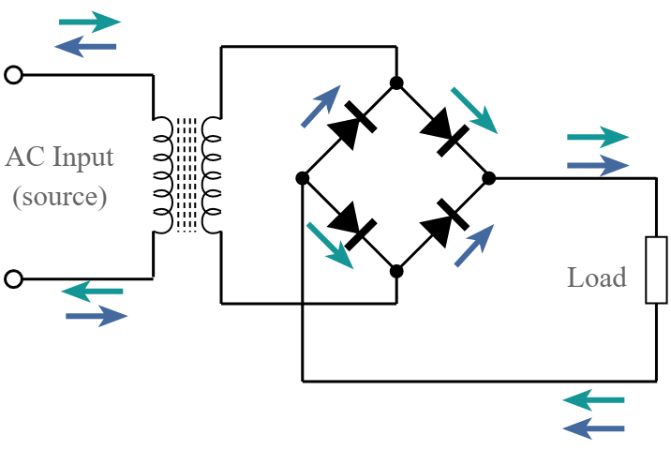[0.3]

There are many designs used for LED light bulbs, however the one shown by the figure below [0.3] is what the circuit designed for this project was inspired by (2). RC circuits are very helpful in filtering unwanted signals when converting AC to DC. Also they are helpful with dampening and slowing the current so the LEDs are not burning out every time the circuit is turned on.

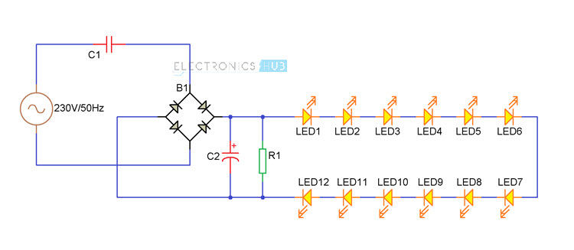[0.4]

3.2 Design Background
The platform used for this design was known from the start of the project. However, this was the only aspect known at first. The first step in generating a good understanding of LED designs came from observing the size and shapes of common LEDs. Once the basic shape was understood, the next aspect was to learn about all the components in a LED. This was done with LED component diagrams found on Google Images [0.4]. Knowing that Solidworks was going to be the tool for design, the final step was to research LED designs created with Solidworks. YouTube made a great search engine for this task as well [1].
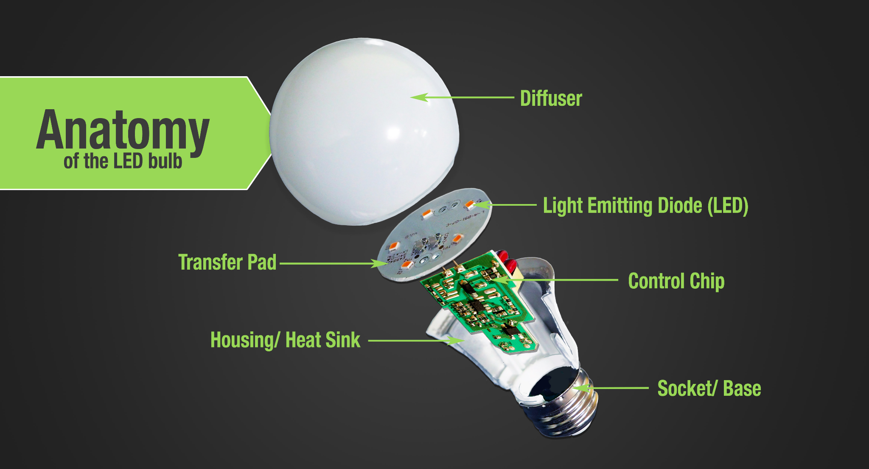[0.5]

3.3 Standards Background
To further understand LED’s we had to look at the standards, an established normal or requirement. The socket/base part is a standardized part meaning it is almost identical to every other lightbulb so they can be easily interchangeable. The following standards along with their descriptions are what will guide the production and testing of this project.
IEC 62031
This document specifies general and safety requirements for light-emitting diode (LED) modules.

DSF/FPREN 63013
This international standard is applicable to LED package for general lighting service

IES TM-26
This document describes three methodologies for projecting the catastrophic failure rate of LED packages.

UL 8750
These requirements cover LED equipment that is an integral part of a luminaire or other lighting equipment. These requirements cover components including LED drivers, controllers, arrays (modules), and packages as defined within this standard.

IES LM-85
This approved method describes the procedures to be followed and precautions to be observed in performing accurate measurements of total luminous flux, total radiant flux (optical power), total photon flux, electrical power, luminous efficacy, color quantities, and wavelength characteristics.

ASME Y-14.1000-2017
This standard is “Engineering Drawing Practices” and shows engineering product definition and related documentation practices standard
ASME Y14.5-2018
This standard is “Dimensioning and Tolerancing” and provides engineering product definition and related documentation practices.
3.4 Manufacturing Background
This is the general outline for how the manufacturing process was created. This allowed for a well designed building to accommodate the needs of this process.
- Research general manufacturing information
- Research plastic molding methods
- Identify applicable standards
- Sketch and modify possible layouts
- Autocad design and Modifications
- Create Autocad layers and sheets

4. PLAN OF ACTION

4.1. First Prototype
4.1. 1 Electric Circuit

For prototype one of the electrical circuit there were three main objectives. The first objective was to make the board function well with the housing part. The second objective was to make sure the circuit worked and turned on the LEDs, as this is the main function of the lightbulb. The final objective was to make a bright and steady light to make the lightbulb usable wherever it is desired. The designs for the first prototype include the schematic (1.0-E) and the board view (1.1-E). Out of the three goals, only one was achieved; which was that there was a consistent DC voltage sent through the LEDs. They however were dim and did not produce enough light to be suitable for its purpose. Also the finished prototype (1.2-E) was slightly larger than the housing piece intended it to be, but the second prototype for the housing piece took this into account so no change was needed to be made.
4.1. 2 Design

For the first prototype, the main objective was to create a basic LED shape with the components found in the background research. The components designed in the first prototype were the housing (1.1), diffuser (1.2), and screw (1.3). The housing and diffuser have lips that snap on to each other for assembly. The diffuser and screw are to be assembled with adhesives. Each component comes with a Solidworks drawing detailing their respective dimensions. Also, there is an exploded drawing of the full assembly for prototype 1. After being 3D printed, the components all fit together. However, the components did not fit with the circuit board. All of the images for the design, drawings, and 3D components can be found under the “Prototype 1, Solidworks” section of the appendices.

4.2. Second Prototype

4.2. 1 Electric Circuit

For prototype 2, the primary objectives were to increase the amount of LEDs within the circuit to create a brighter light than prototype one and to match the pins of the components with the through holes. Both of these goals were achieved and can be seen on the schematic [2.0-E] and the board view [2.1-E] as the amount of LEDs were increased from eight to twelve and the components were increased in size.

4.2. 2 Design

For the second prototype, the main objective was to make the components fit with the circuit board. In order to achieve this, the housing and diffuser were redesigned. The lip on this new housing component was redesigned with a rim to hold the circuit board [2.1-M]. This updated design successfully fit the circuit board. The updated diffuser’s lip was also altered. Instead of latching, it sits in the housing [2.2-M]. These two components will now be held together by an adhesive. After 3D printing the parts, the two components did not fit together at the connection point. Drawings of the updated components as well as an exploded view of the updated assembly can be seen under “Prototype 2, Solidworks” in the appendices. The updated designs and printed parts can also be found under “Prototype 2, Solidworks” in the appendices.

4.3. Third Prototype

4.3. 1 Electric Circuit

For the third and final prototype there were two objectives, these were to make all the components on the schematic [3.0-E] SMT and to clean up the layout of the components on the board layout [3.1-E]. Both goals were completed and were done to finalize the design of the circuit which will be used in the final manufacturing process.

4.3. 2 Design

For the third prototype, the main objective was to make a complete LED unit. In order to achieve this, the flaws from prototype 2 were solved. This was done by changing the lip on the housing from prototype 2, thus producing an updated housing component [3.1-M]. Along with the updated housing, a circuit board was designed and printed for modeling purposes [3.4-M]. The third prototype successfully produced a complete unit that functions on all levels. Images of the updated housing design, printed part, and drawing can be found under “Prototype 3, Solidworks” in the appendices. The final assembly with an exploded drawing can also be found under “Prototype 3, Solidworks” in the appendices.

4.4. Manufacturing Process

Our goal for the manufacturing aspect of this project is to efficiently mass produce a quality product. We need a well designed process to accomplish this. The following diagrams together show which each box represents and how long that task will take to accomplish.

1 | N/A | 3 Minutes | Metal Cutter
2 | 1 | 1 Minute | Metal Press
3 | N/A | 2 Minutes | Air Press
4 | N/A | 30 Seconds | Plastic Input
5 | 4 | 10 Seconds | Plastic extruder
6 | 3,5 | 1 Minute | Blow Molder
7 | 6 | 30 Seconds | Cooling and Polishing
8 | N/A | 2 Minutes | Wire Splicer
9 | 8 | 2 Minutes | Electronic Assembly
10 | N/A | 1 Minute | Base Feed
11 | 10 | 30 Seconds | Base alignment
12 | 9 | 1 Minute | Glue
13 | 7 | 1 Minute | Glue/Mounting
14 | 2 | 1 Minute | Stamping and Packaging
Total time |  | 11 minutes and 10 seconds
Figure [1-M]

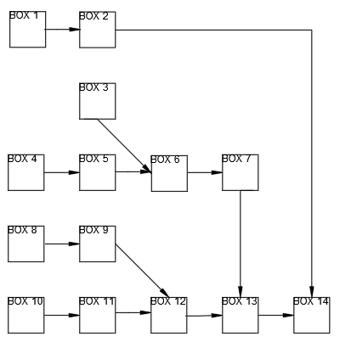
Figure [2-M]
The following diagram shows the dimensions of the building, in meters. This shows the scale of the delivery door, located on the top wall. There is also an ADA compliant door located in the bottom right of the building. The machines, the one meter by one meter, boxes have one meter of space separating them from each other to leave room for maintenance and to be easily able to work around. The two by two meter storages have plenty of space to hold all the necessary raw materials along with any finished products. There is a largely unused area on the right side for any future expansions, offices, or break rooms that can be easily implemented.
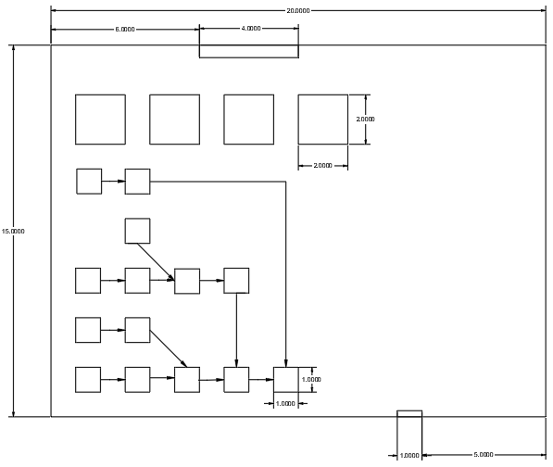
Figure [3-M]

The following diagram shows the different distribution of the types of materials. The green at the top are the storages, which are conveniently located by the loading docks. The yellow is for the metal which we will be producing in house. The gray is for plastic moldings. The purple is for the electronic wiring. The blue is for the base and assembly.

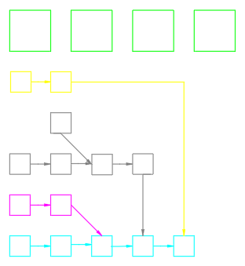
Figure [4-M]

4.5. Project Timeline
A Gantt chart is a project management tool that illustrates a project plan. In general, it comprises two sections: the left side describes a list of tasks, while the right side has a schedule with schedule bars that visualize the work. The Gantt diagram also includes task start and finish dates, milestones, task dependencies, and assignees.
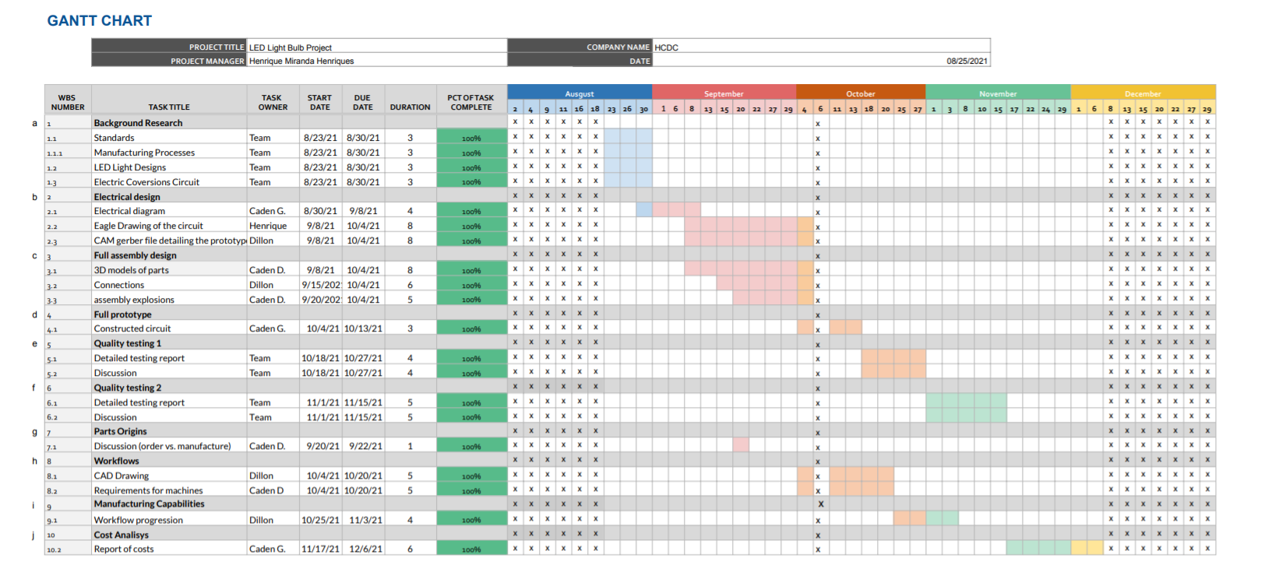
Gantt Chart Figure

5. ENGINEERING GROUP CAPABILITIES
Each member of HCDC plays an important role for the development of this project. Every single member is skilled in their own area of expertise and together we form a capable and responsible team .

5.1. Qualifications and Experience
As a manager, Henrique H. has skills to guide and assign deliverables to each member of the team, organize the project in order to have every member working at the same time in different aspects of the project, managing the timeline as it was smoothly and efficiently. Caden D. is an important member and very skilled on the design of the lightbulb, working with solidworks and printing, re-doing, fixing and completing his part of the project. Caden G. is an electric circuits specialist, he drew the circuit board design, studied the components and tested them for a better efficiency. Dillon B. is the specialist in the manufacturing process respecting the standards to produce light bulbs, his abilities to manage how it is produced and studying the step-by-step to manufacture it, helps us conclude his part for the project. The members of HCDC are the key for the company to work properly, their work ethic and commitment are very important and essential for this project

5.2. Equipment and Facilities
Doane University has provided us with all the equipment necessary for the completion of this project. Doane University has several 3D printers, an amazing environment with tools such as a soldering machine, pliers, multimeters, power supply, breadboard, wires, and many others, an endless resource place. The circuit was mounted and tested within Doane, the 3d models were designed and printed at the same place.

6. PROPOSAL IMPACTS

The big advantage of the LED lamp is the energy savings it provides of up to 80% specifically. That's because the diode has a good luminous capacity, making the light output greater using less energy. As they do not have metallic filaments, mercury or toxic substances in the composition, the LED lamp does not emit pollutants into the environment and can still be recycled.

6.1. Impacts to Client

Strengths | Weaknesses
- Simple Design  - Reliable  - Efficient | - Speed  - Cost  - Start up cost
Opportunities | Threats
- Expansion  - Innovation  - Recycle | - Wasted Space  - Competitiveness

6.2. Broader Impacts
As this type of lighting helps to reduce electricity consumption, it means less carbon emission into the environment. LED lamps also do not emit UV radiation and have no mercury in their composition. This means that they can be used in environments where this type of radiation is not wanted.

6.3. Itemized Costs

Components ordered to build one light bulb:

Item | Description | Series | Quantity | Vendor or Provider | Cost per Item
E01 | Capacitor 250V | C2012X5R2E332M085AA | 2 | Digi-key | $0.19
E03 | Resistor 150kΩ | RE0805FRE07150KL | 2 | Digi-key | $0.10
E04 | Bridge Rectifier  (4 diodes) | V2PM12HM3/H | 1 | Digi-key | $0.38
E05 | LED Light (8mm) | 158301230A | 8 | Digi-key | $0.26
E07 | Circuit Board | Own design | 1 | JLCPCB | $0.40
M05 | Socket/Base | E27 | 1 | Digi-key | $3.80
Add the | Mechanical parts | Or take out the socket | and | Make this an electrical parts | list
TOTAL COST |  |  |  |  | 8.38

7. REFERENCES
This will include a list of ASME-formatted citations of any sources used to generate this proposal. Note: ALL distributor information will be linked as references, and must have in-text citations. A document that does not include in-text citations, but has references, is still considered plagiarized.
- SolidWorks LED Bulb Tutorial || Rahul Dewangan || Mrbhaiyaji.Com. www.youtube.com, https://www.youtube.com/watch?v=qGYUovYl4kI. Accessed 15 Sept. 2021.
- “DIY LED Light Bulb (LED Lamp).” Electronics Hub, 13 Oct. 2017, https://www.electronicshub.org/diy-led-light-bulb/.
- Bridge Rectifier Circuit - Design Details & Tips » Electronics Notes. https://www.electronics-notes.com/articles/analogue_circuits/diode-rectifiers/full-wave-bridge-rectifier.php. Accessed 15 Sept. 2021.
- UPenn, Liz MillerLiz is the Founder of Learn Robotics She holds a B. S. in Robotics Engineering from WPI Liz has a multitude of robotics experiences ranging from being a Robotics Researcher at, et al. “How To Surface Mount Solder in 3 Steps.” Learn Robotics, 2 May 2019, https://www.learnrobotics.org/blog/surface-mount-solder-tutorial/.
- “Through Hole vs Surface Mount: Which Should You Use?” PCB Design & Engineering Services, 26 July 2018, https://www.freedomcad.com/2018/07/26/through-hole-vs-surface-mount-which-should-you-use/.

8. APPENDICES
Background:
[0.1] shows the layout of a throughhole board
[0.2] shows the layout of a SMT board
[0.3] shows how a bridge rectifier works
[0.4] shows the inspiration of the circuit design
[0.5] shows the anatomy of an LED bulb.
[0.1]
[0.2]
[0.3]
[0.4]
[0.5]

Prototype 1, Electrical Circuit:
[1.0-E] shows the schematic of the prototype 1 circuit
[1.1-E] shows the board view of the prototype 1 circuit
[1.2-E] shows the completed board of the prototype 1 circuit
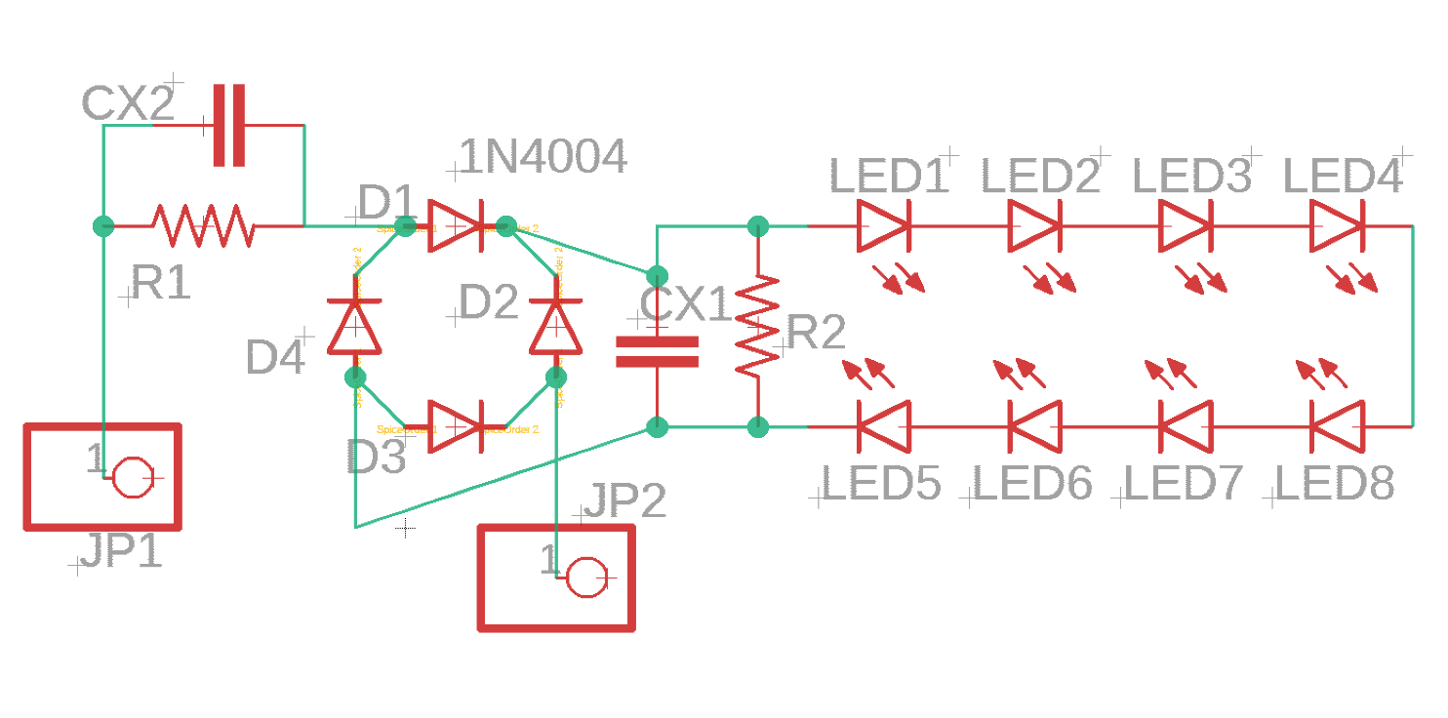[1.0-E]
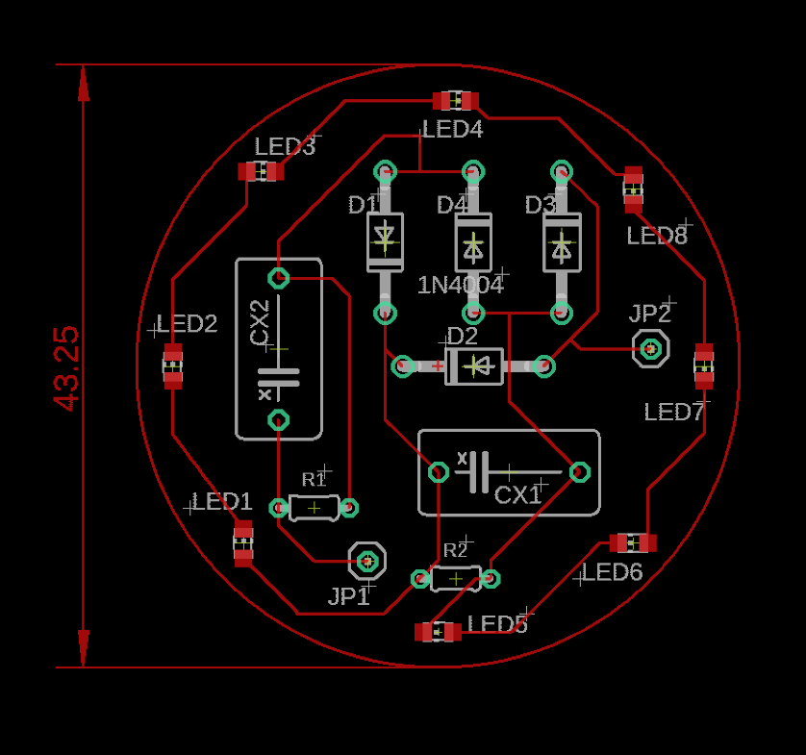[1.1-E] 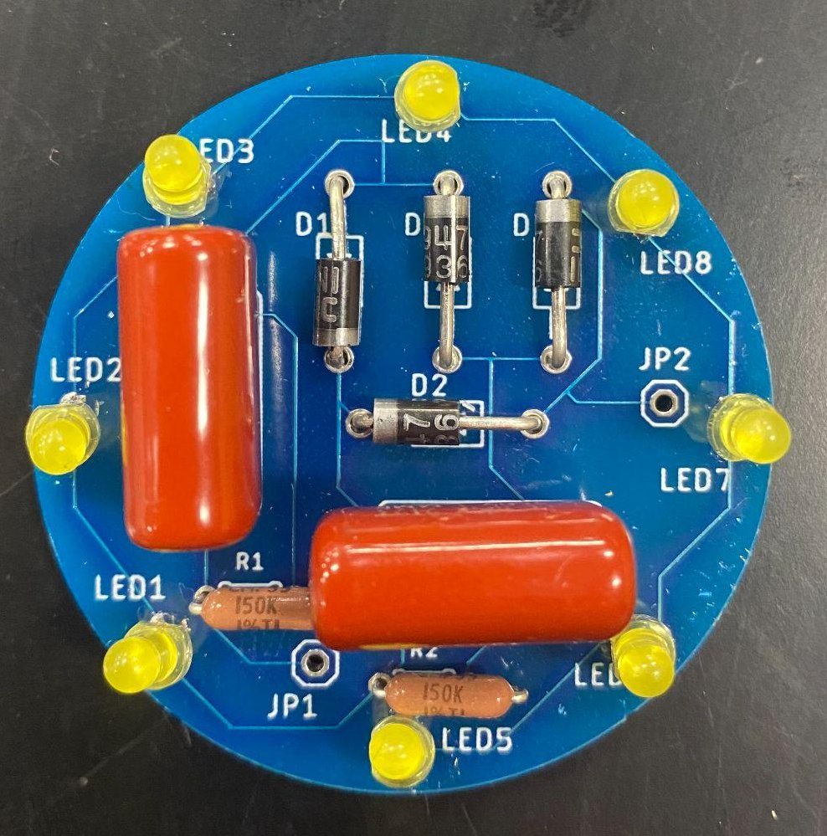[1.2-E]

Prototype 2, Electrical Circuit:
[2.0-E] shows the schematic of the prototype 2 circuit
[2.1-E] shows the board view of the prototype 2 circuit
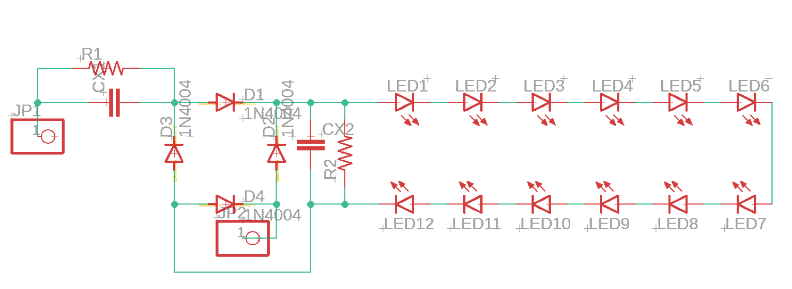[2.0-E]
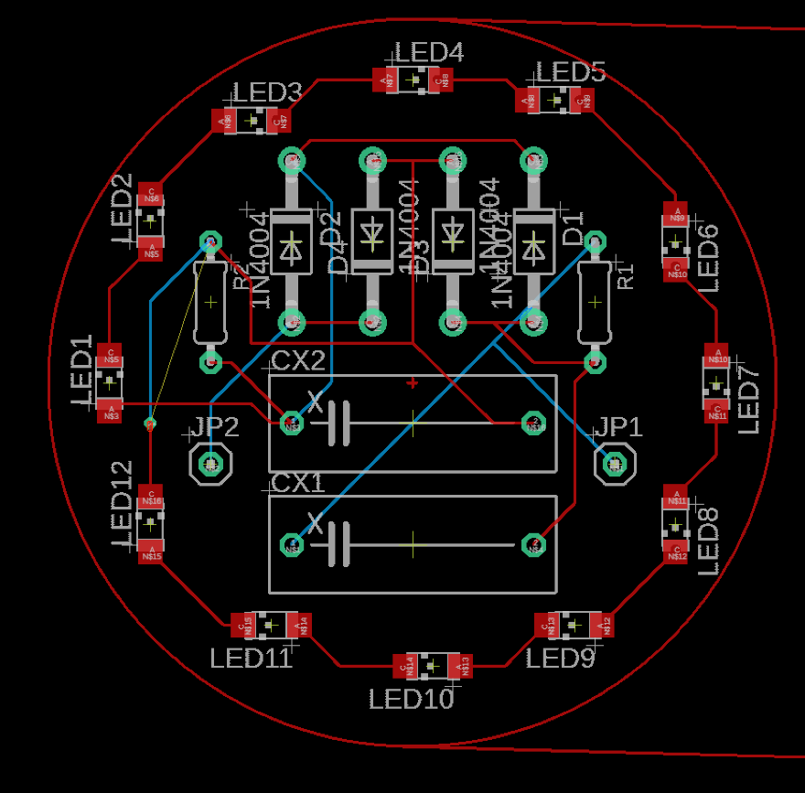[2.1-E]

Prototype 3, Electrical Circuit:
[3.0-E] shows the schematic of the prototype 3 circuit
[3.1-E] shows the board view of the prototype 3 circuit
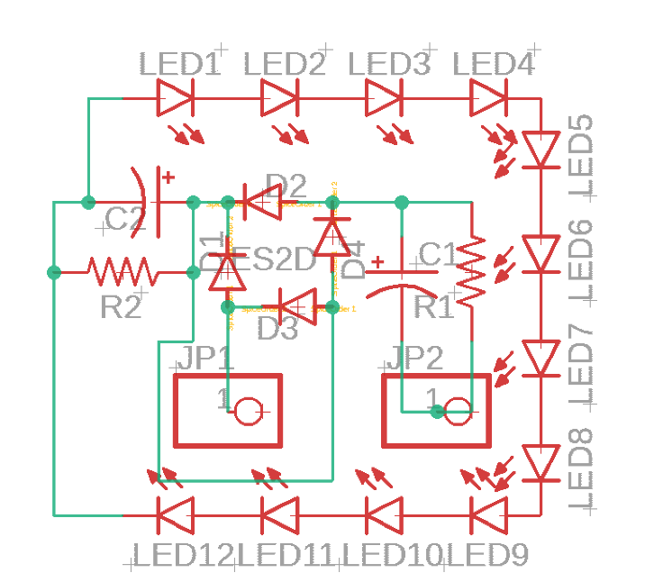[3.0-E]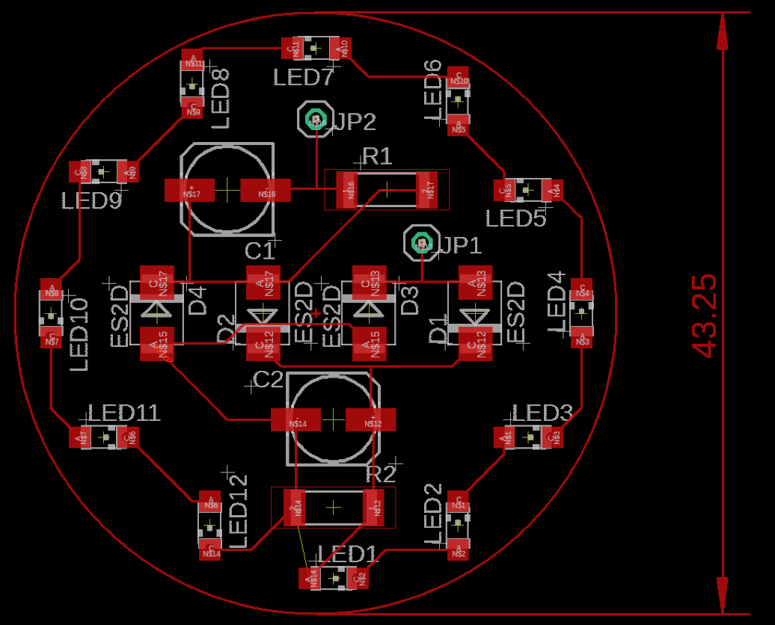[3.1-E]

Prototype 1, Solidworks:
Prototype 1 modeling:
[1.0-M] shows the exploded assembly of prototype 1
[1.1-M] shows the design of housing 1.1
[1.2-M] shows the design of diffuser 1.2
[1.3-M] shows the design of screw 1.3
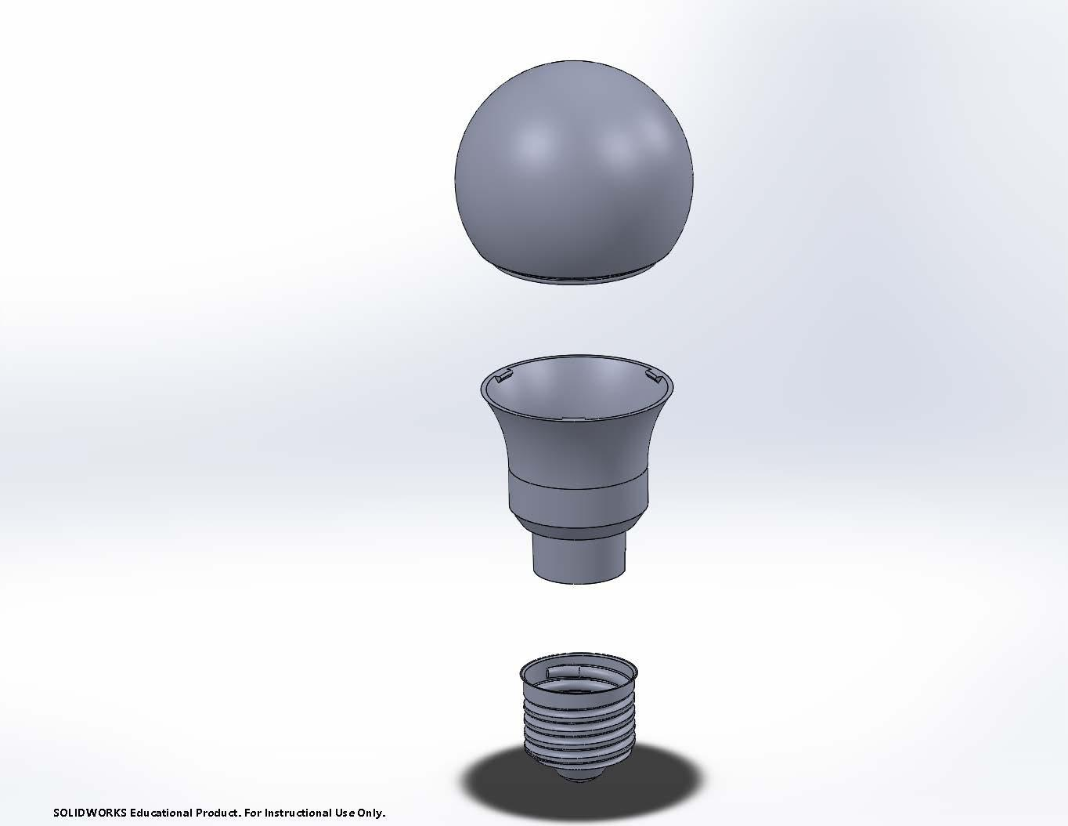[1.0-M]
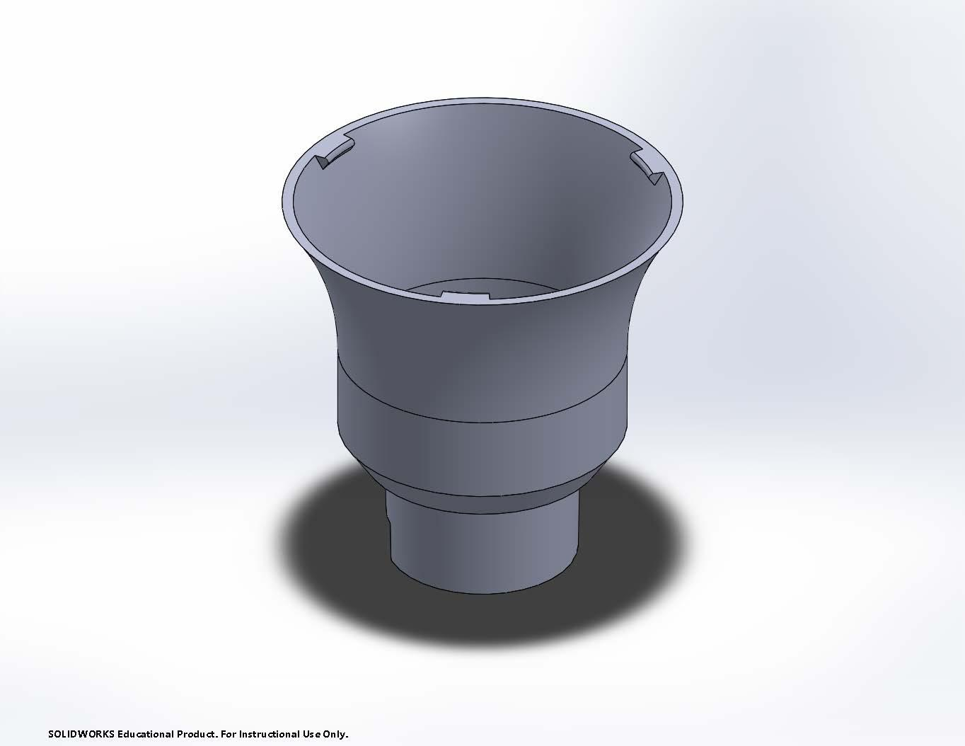[1.1-M]

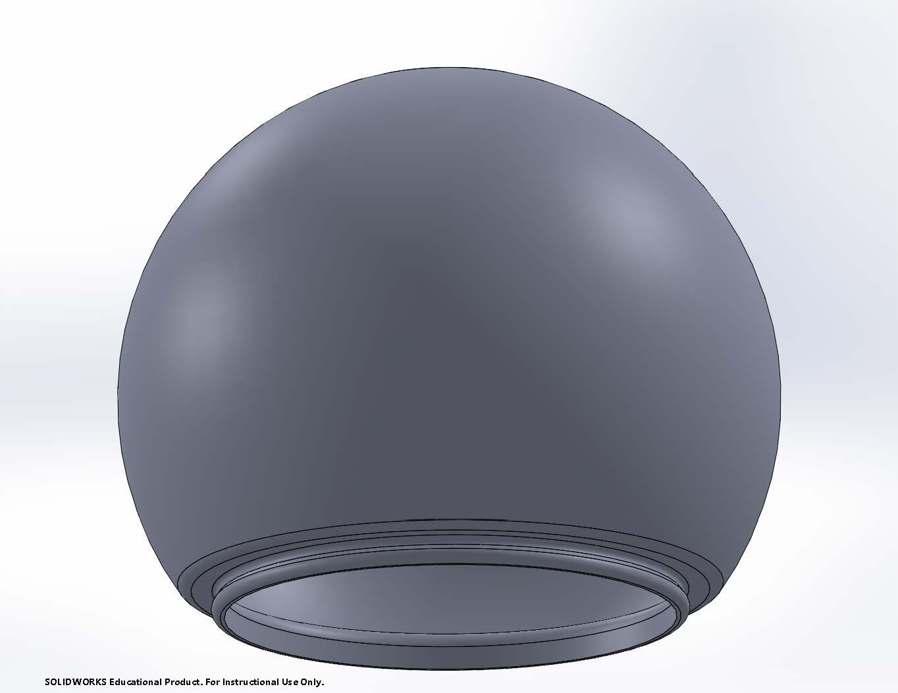[1.2-M]
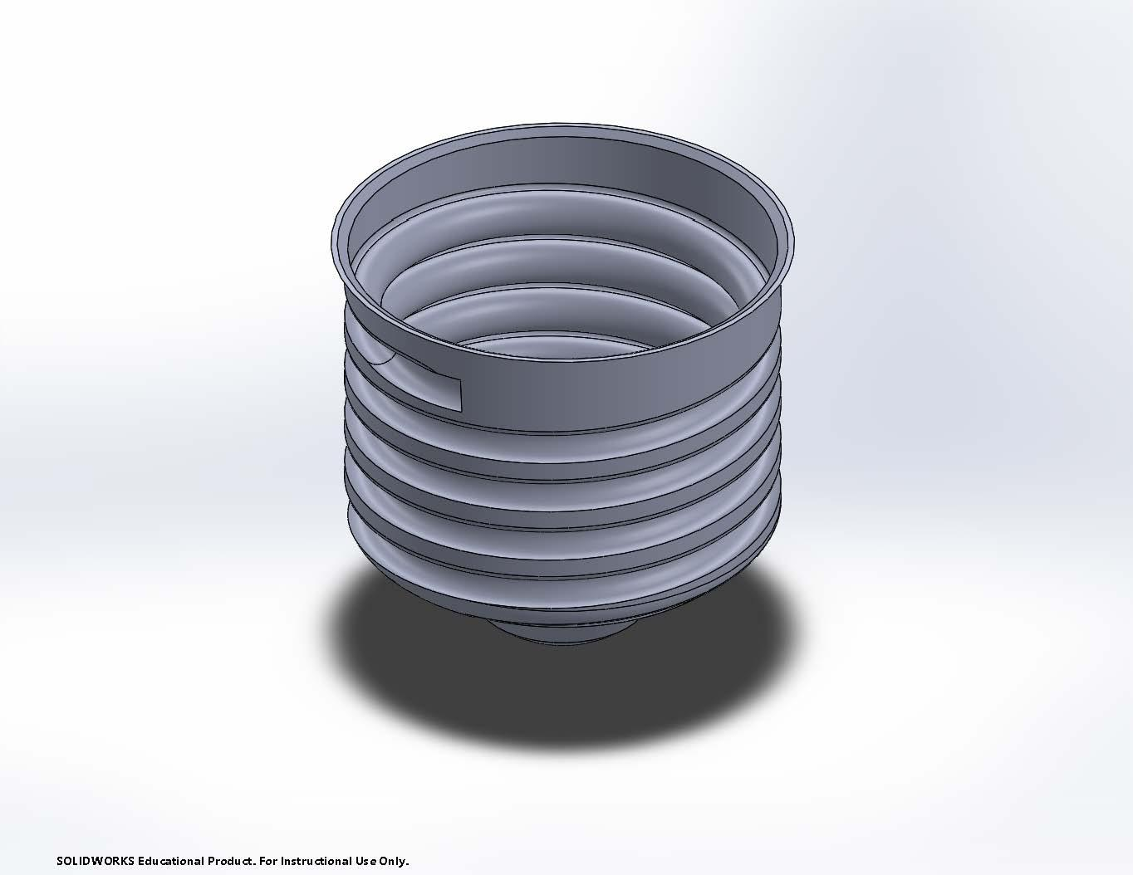[1.3-M]

Prototype 1 Drawings:
[1-D] shows the exploded assembly drawing of prototype 1.
[1.1] shows the housing component dimensions.
[1.2] shows the diffuser component dimensions.
[1.3] shows the screw component dimensions.
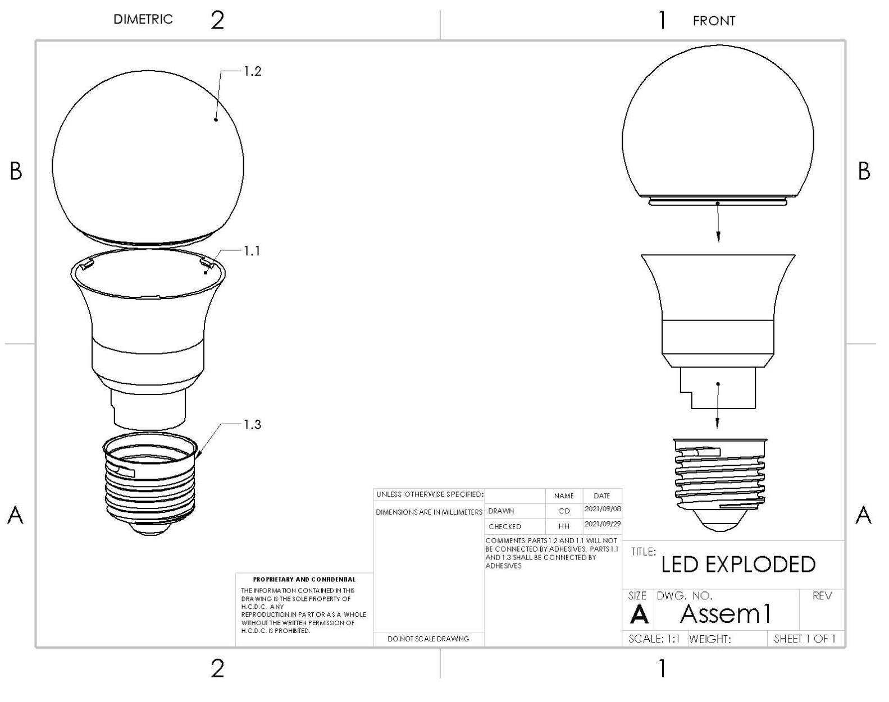[1-D]
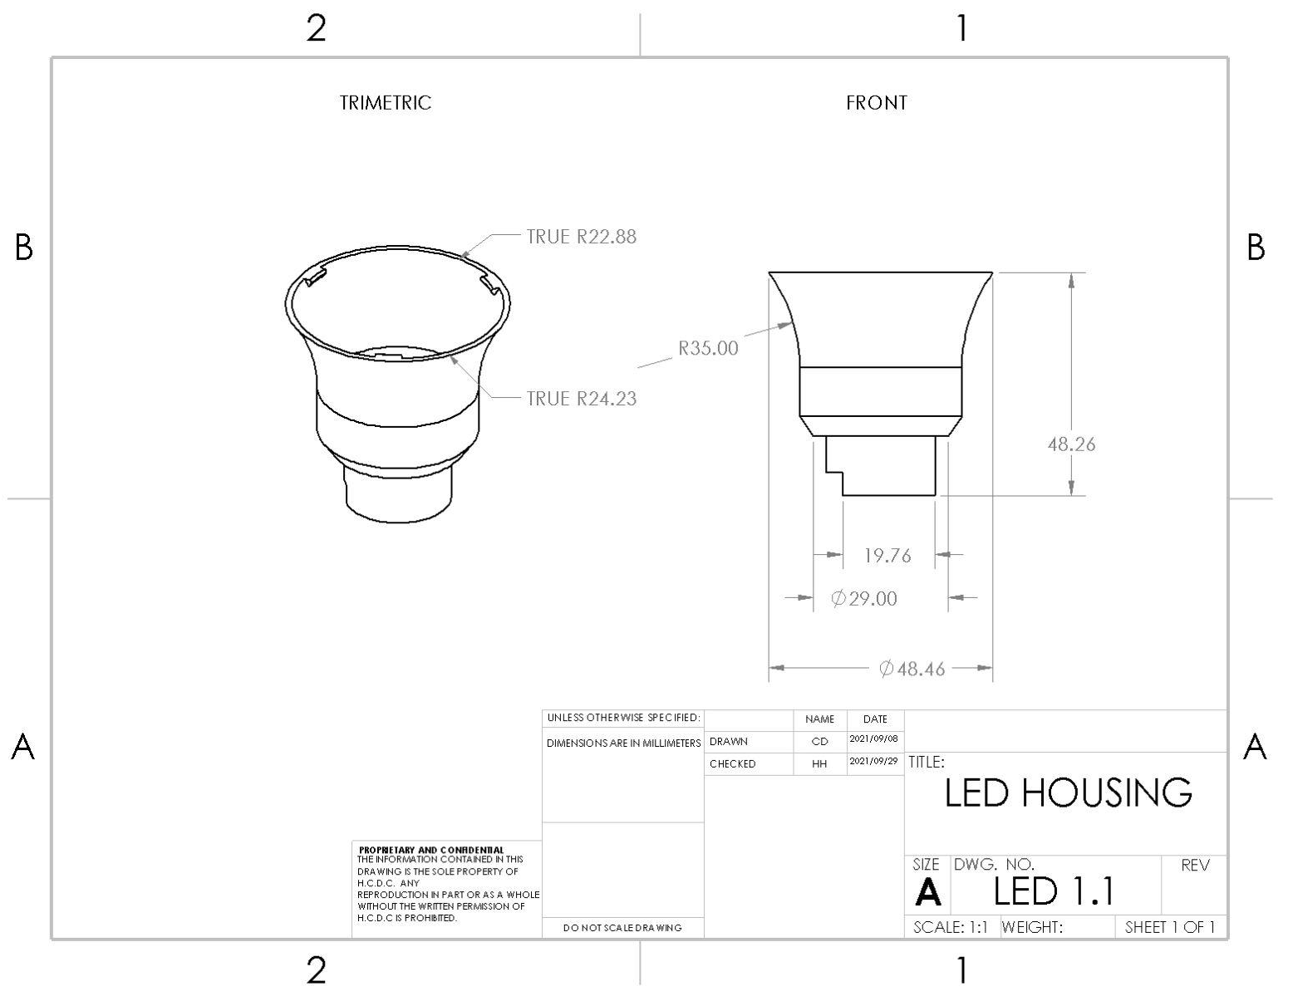[1.1-D]

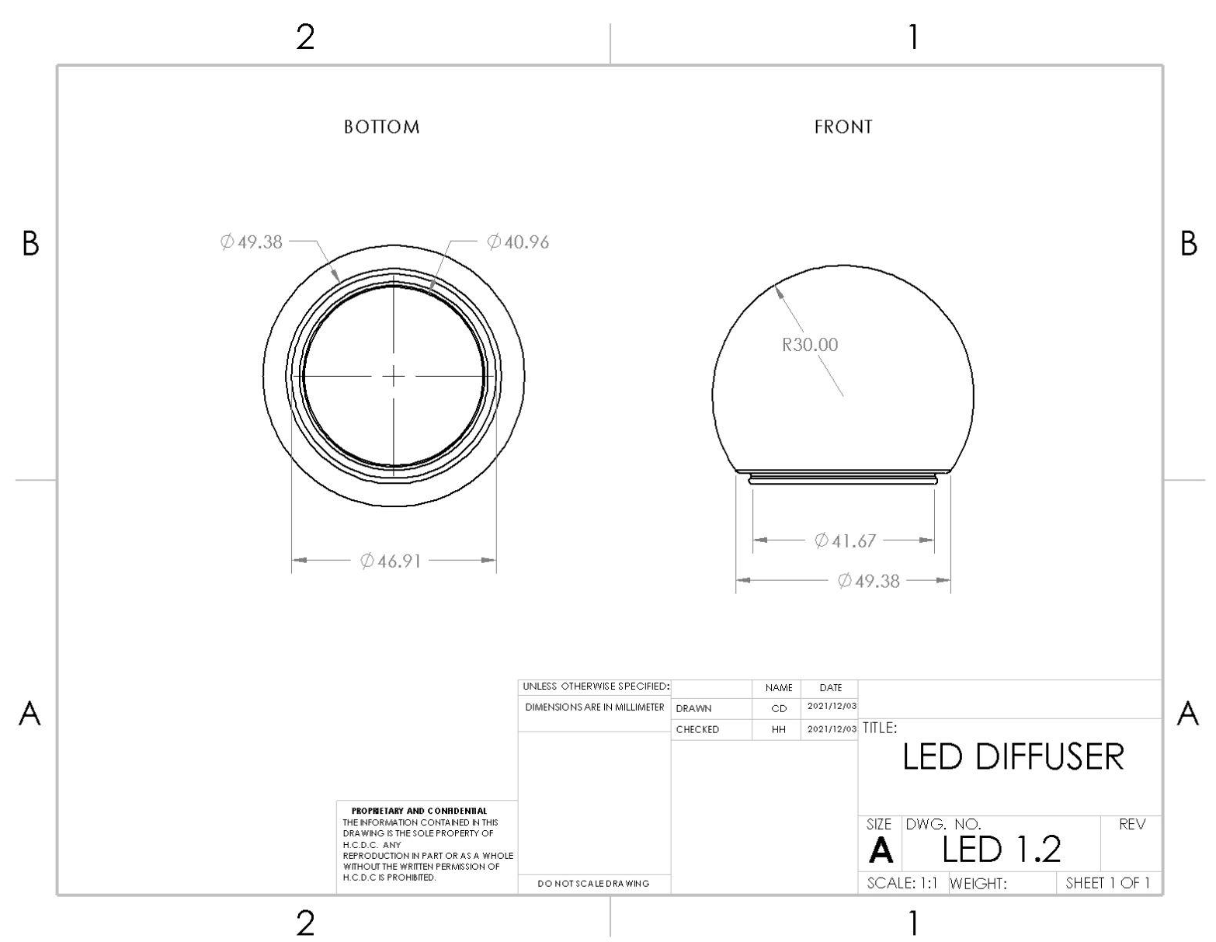[1.2-D]

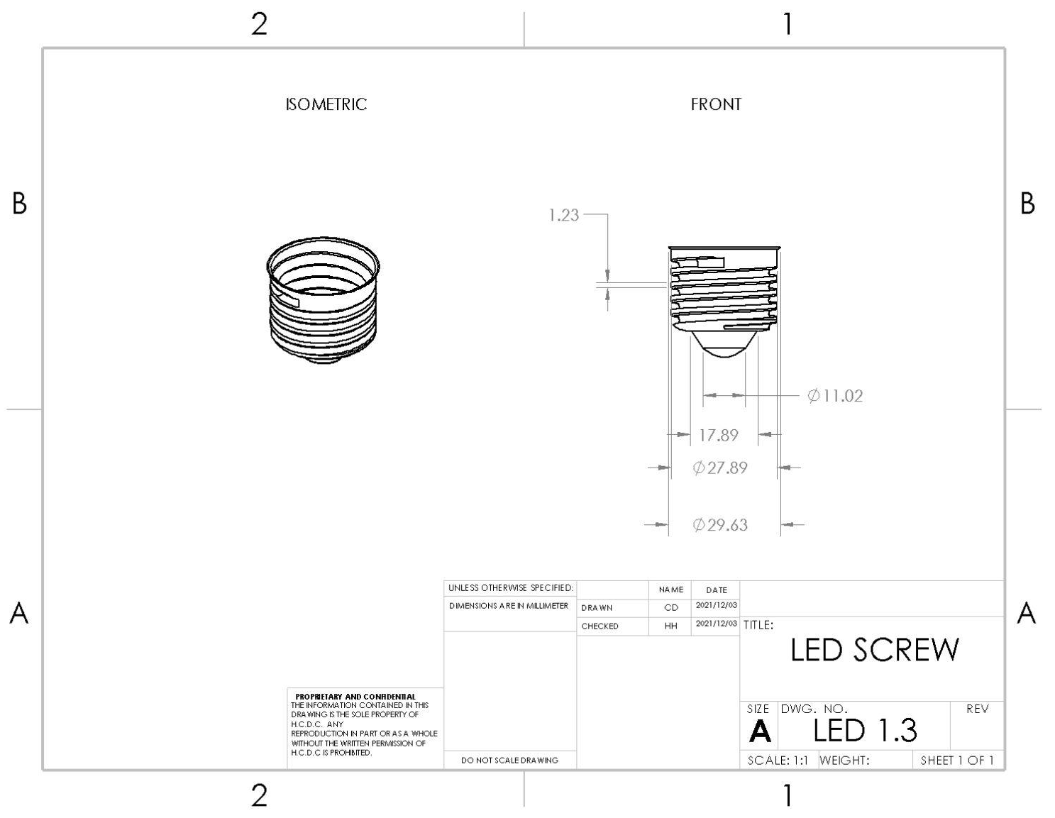[1.3-D]

3D Printed Parts:
[1.1-P] shows the 3D printed housing.
[1.2-P] shows the 3D printed diffuser.
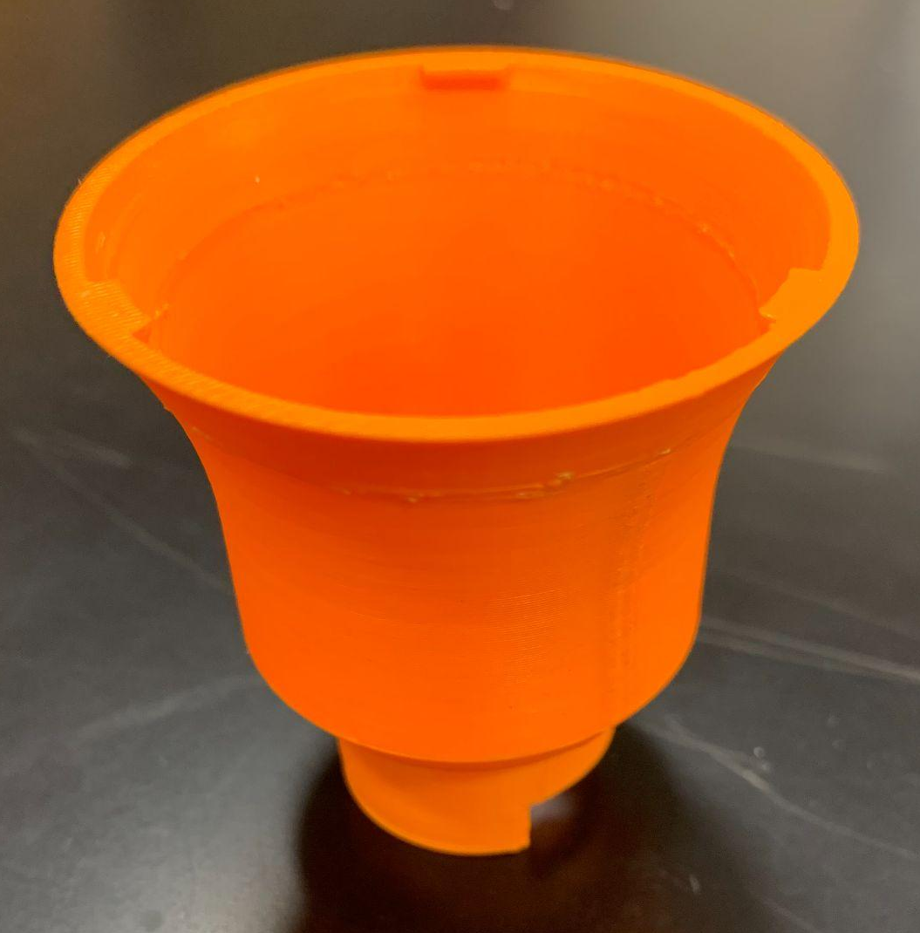[1.1-P]

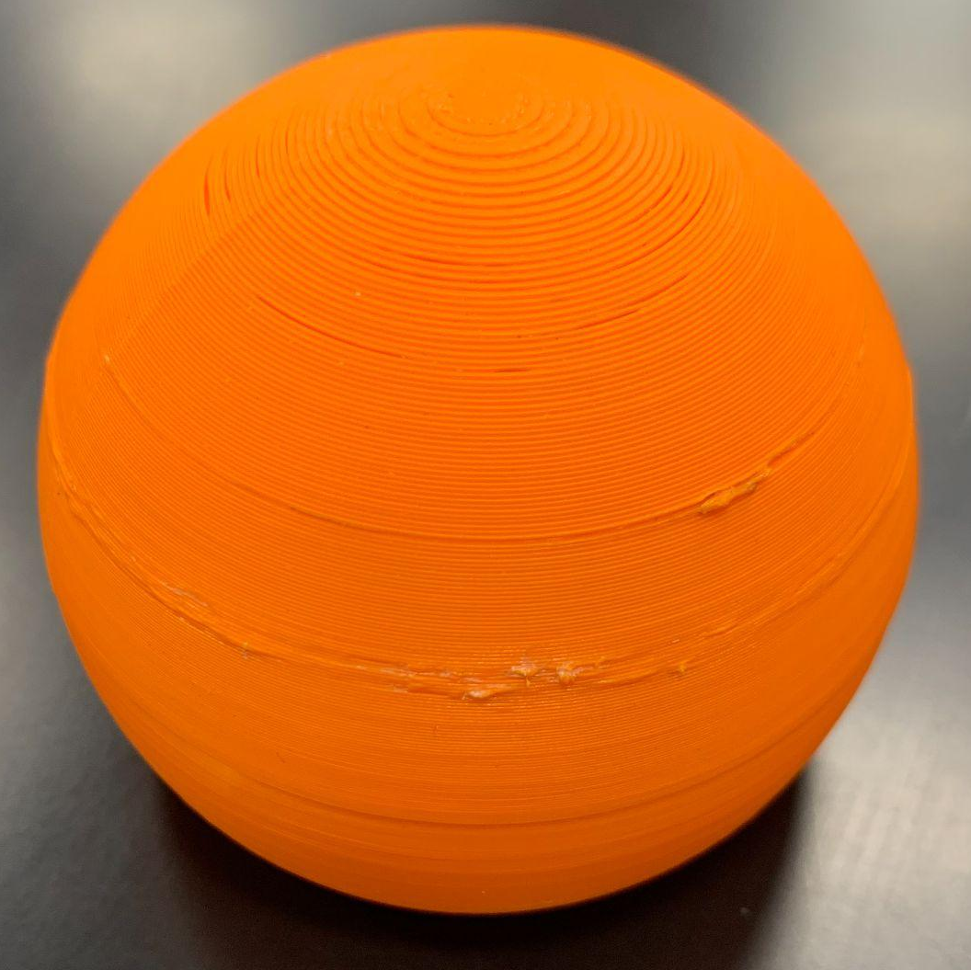[1.2-P]

Prototype 2, Solidworks:
Prototype 2 Modeling:
[2-M] shows the exploded view of prototype 2.
[2.1-M] shows the design of housing 2.1.
[2.2-M] shows the design of diffuser 2.2.
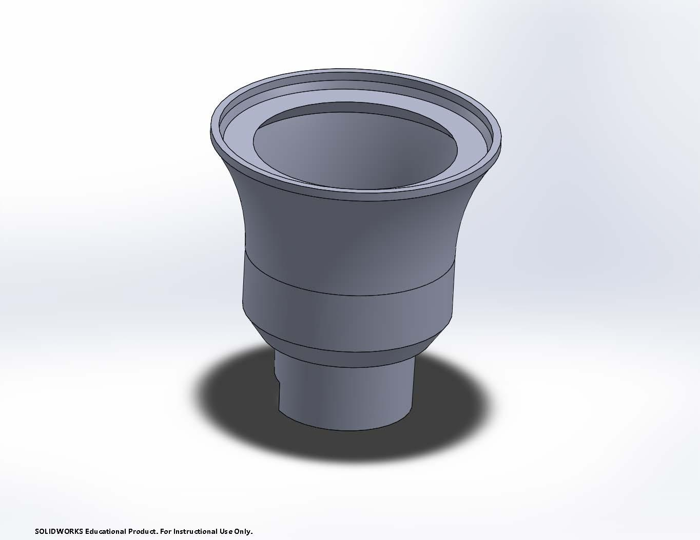[2.1-M]
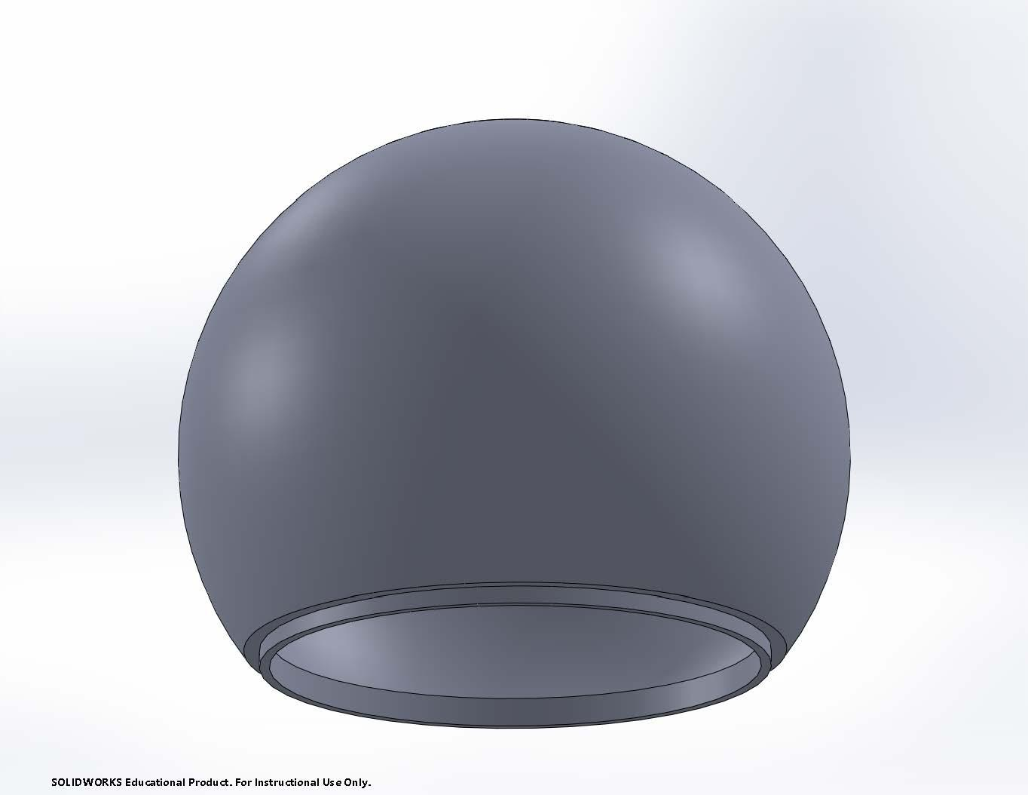[2.2-M]

Prototype 2 Drawings:
[2-D] shows the exploded drawing of prototype 2.
[2.1-D] shows the dimensions of housing 2.1.
[2.2-D] shows the dimensions of diffuser 2.2.
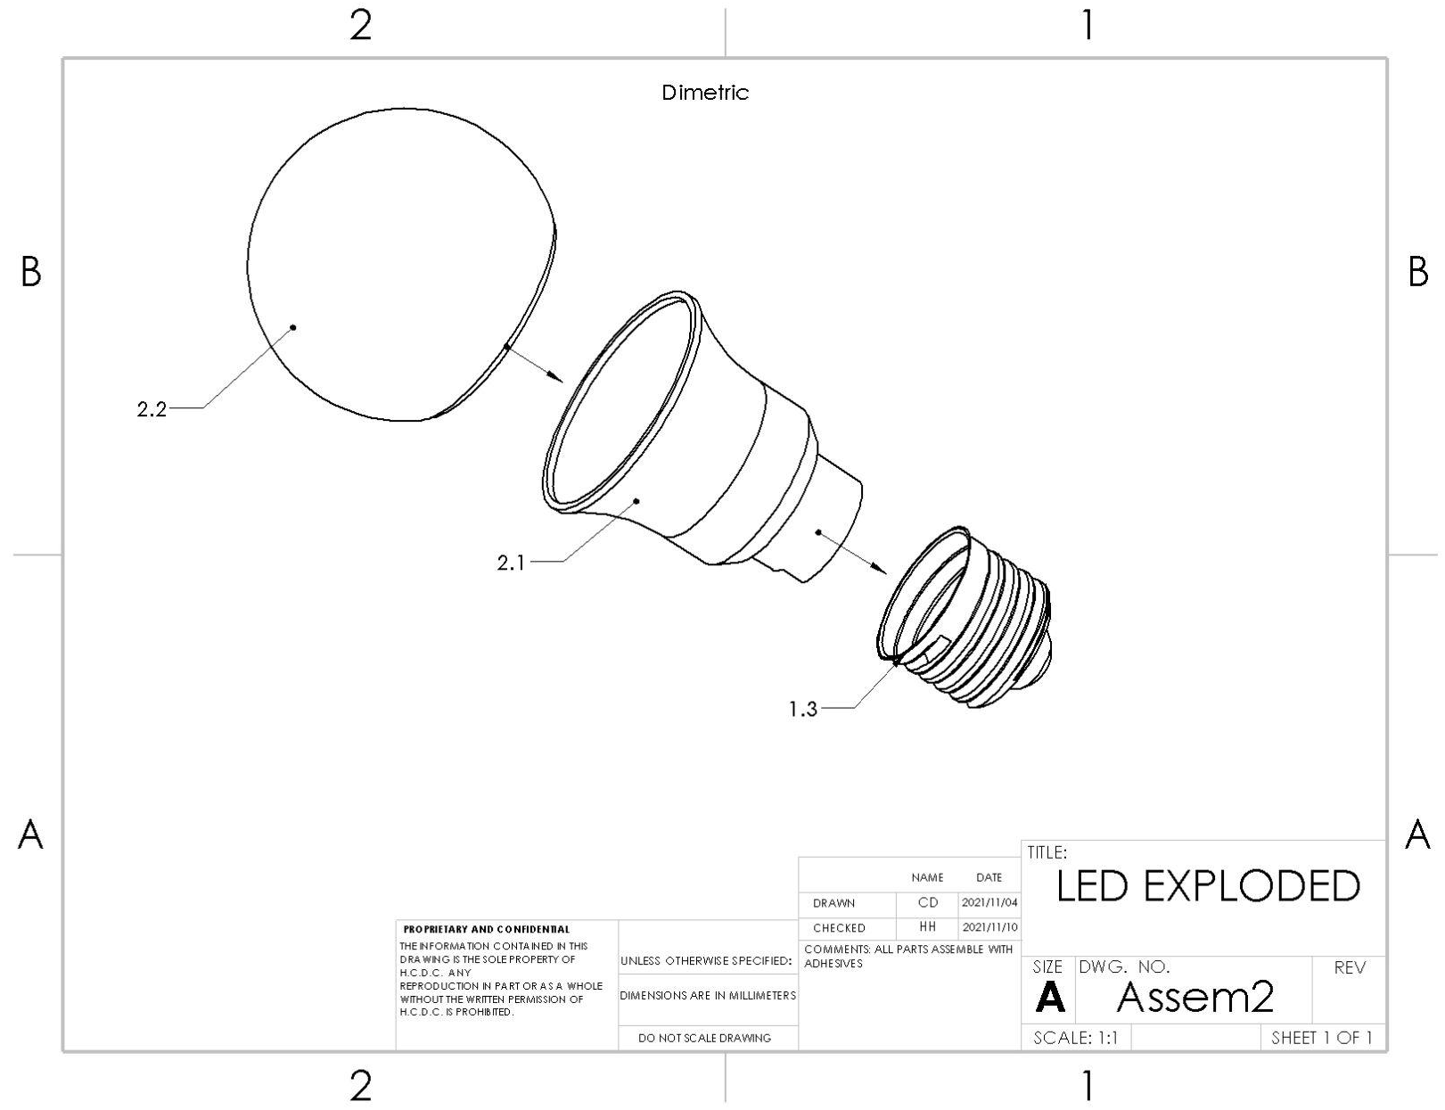[2-D]
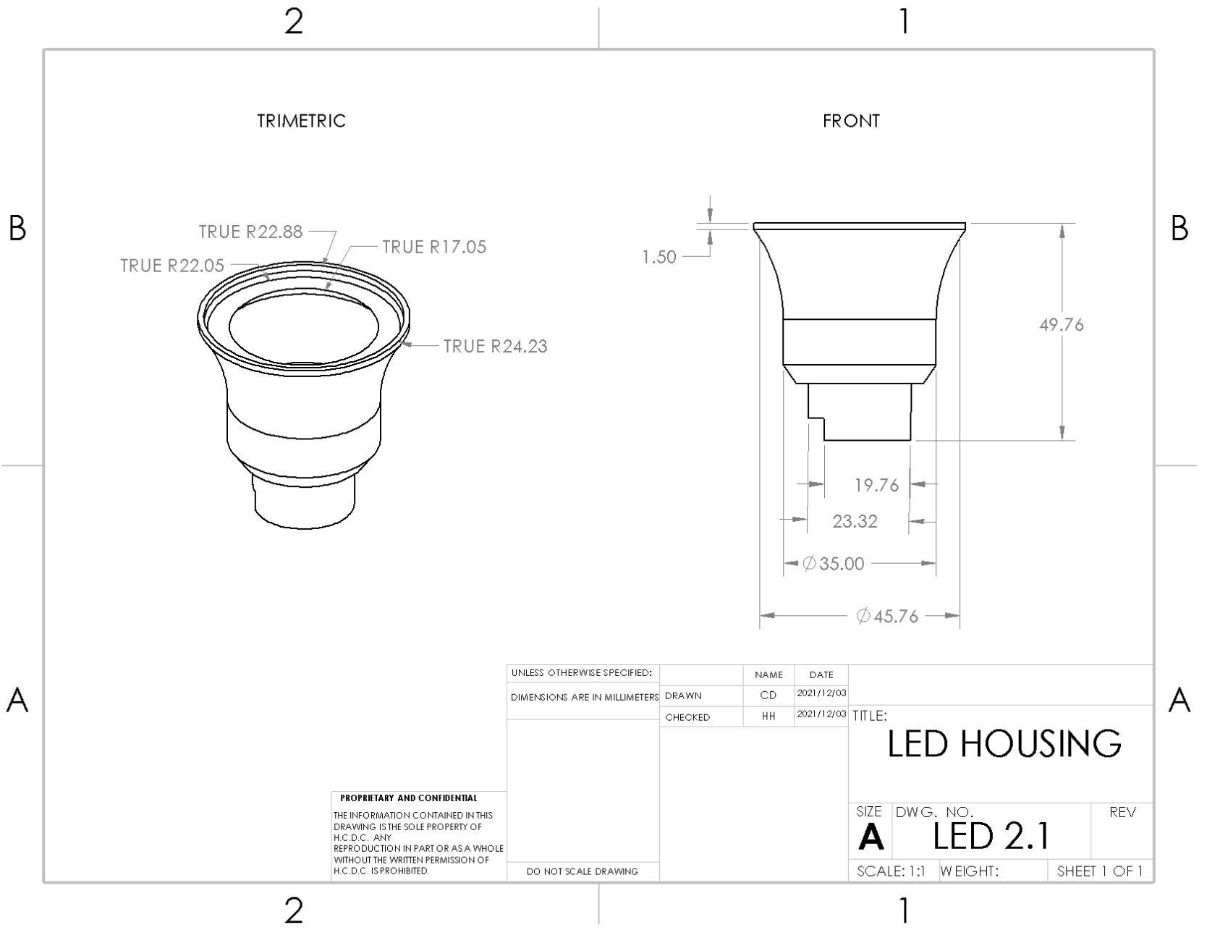[2.1-D]
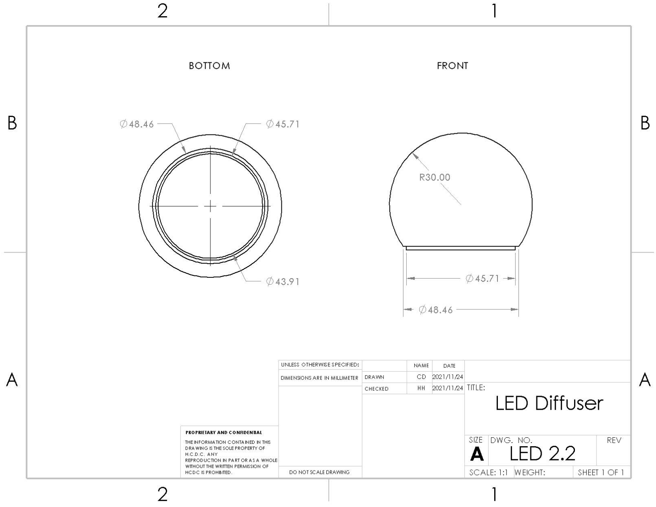[2.2-D]
Prototype 2 3D printed parts:
[2.1-P] shows…
[2.2-P] shows the printed diffuser 2.2.

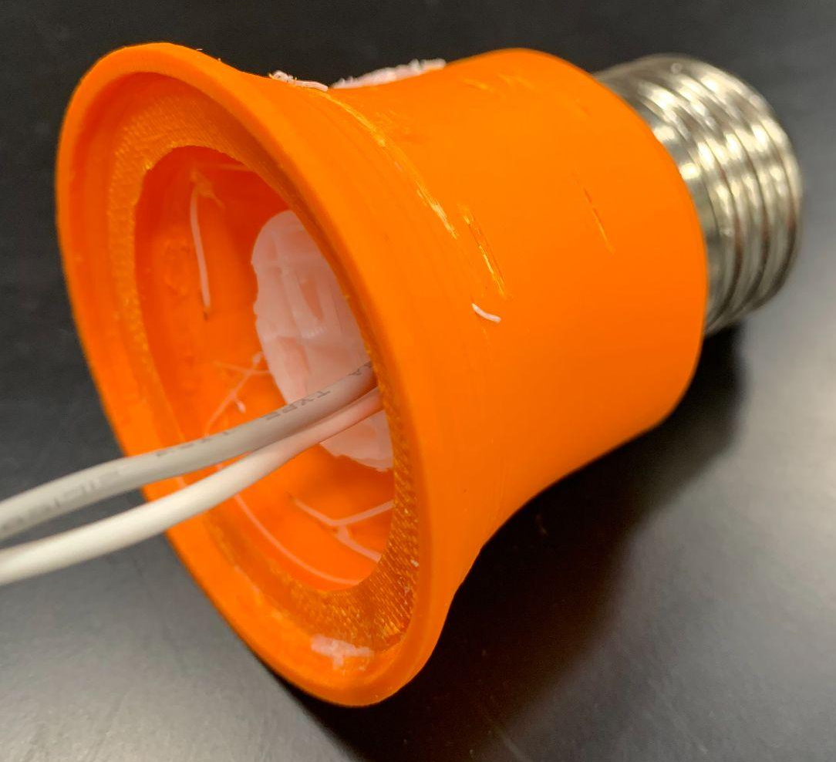[2.1-P] 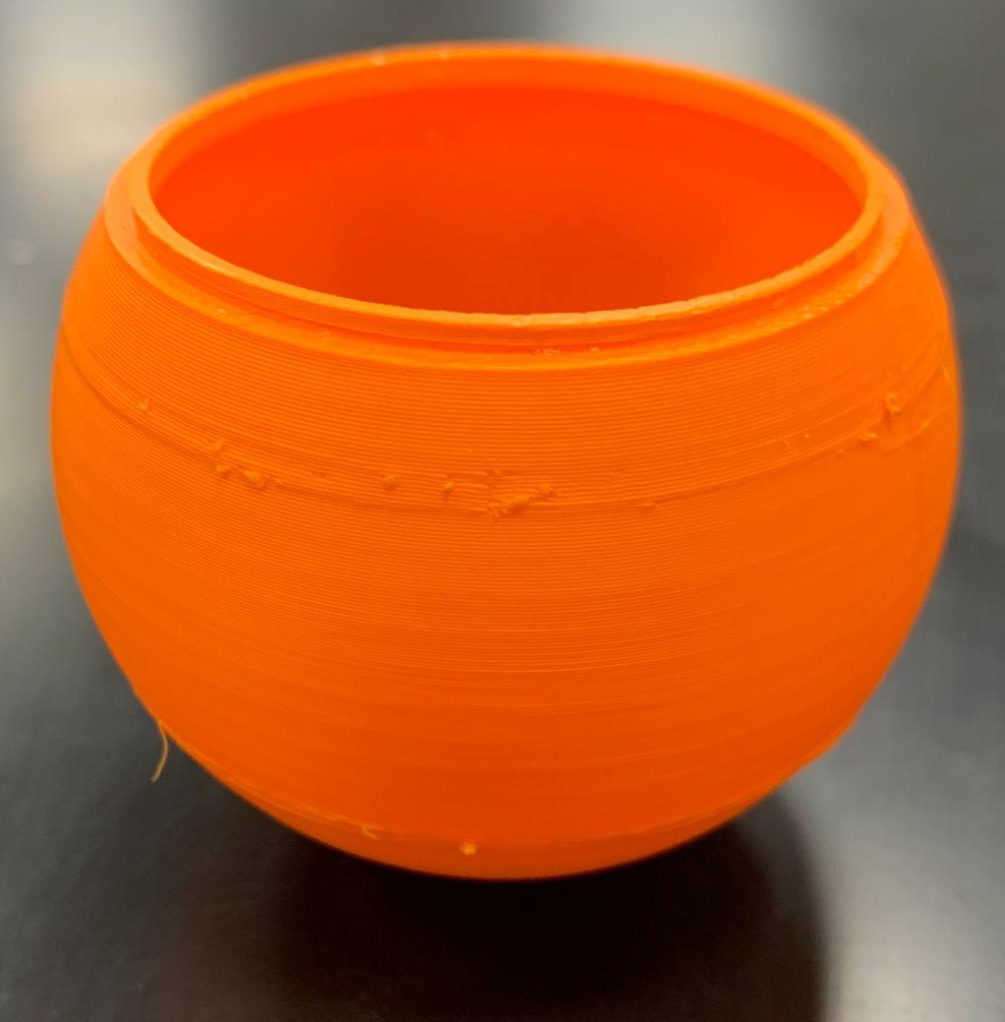[2.2-P]

Prototype 3, Solidworks:
Prototype 3 modeling:
[3-M] shows the exploded assembly of prototype 3
[3.1-M] shows the design of housing 3.1
[3.4-M] shows the design of circuit board 3.4
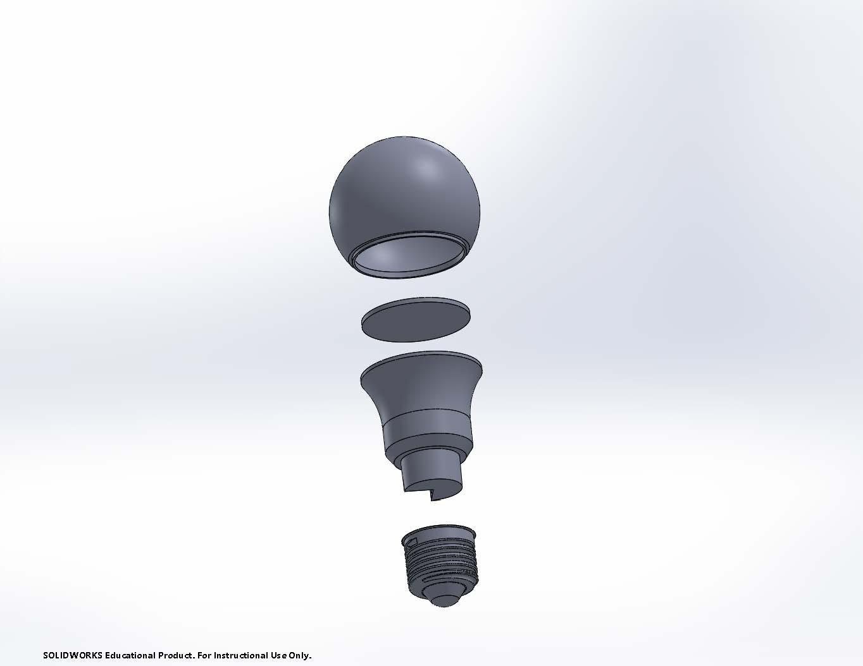[3-M]
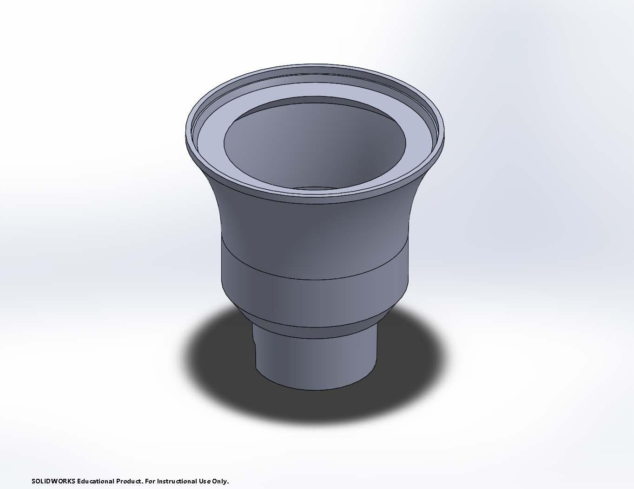[3.1-M]

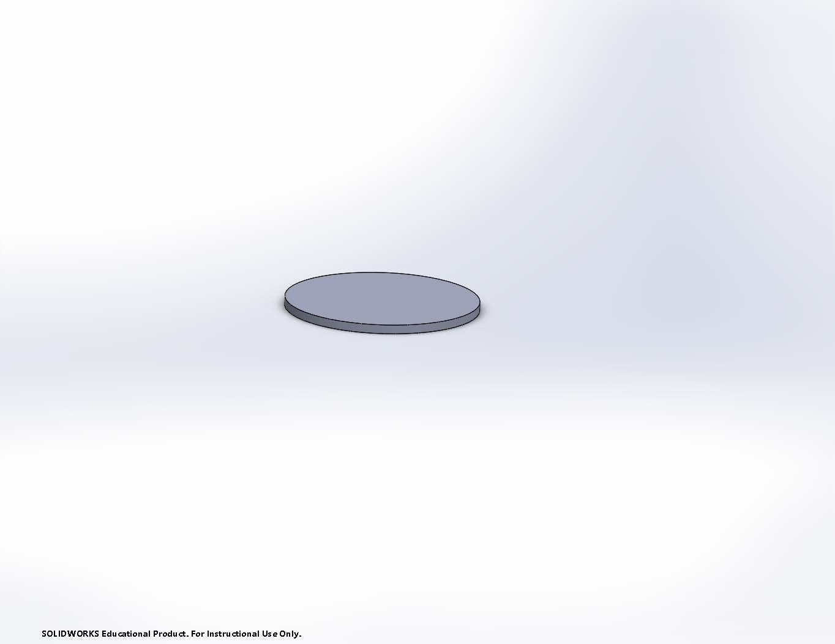[3.4-M]

Prototype 3 Drawings:
[3-D] shows the exploded drawing of prototype 3.
[3.1-D] shows the dimensions of housing 3.1.
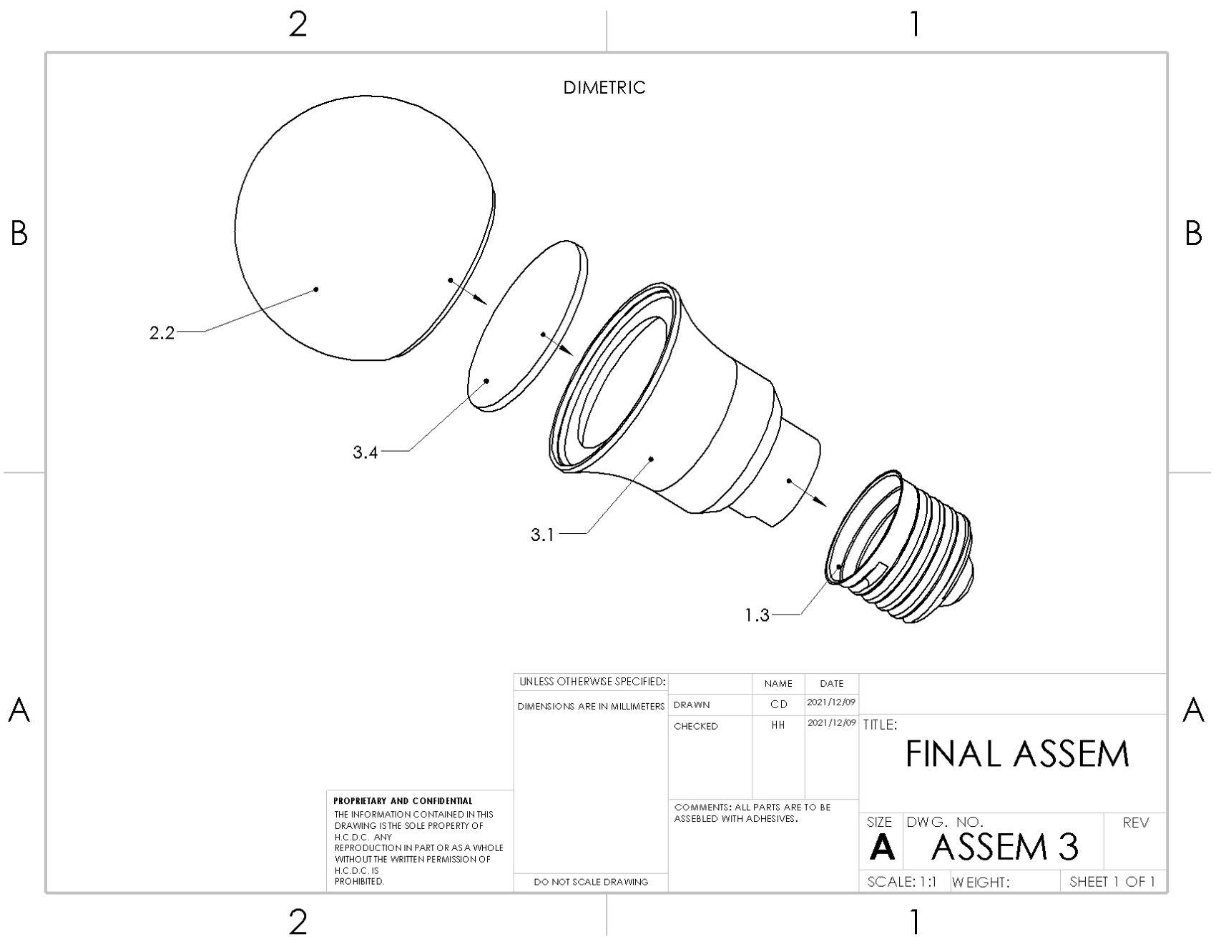[3-D]
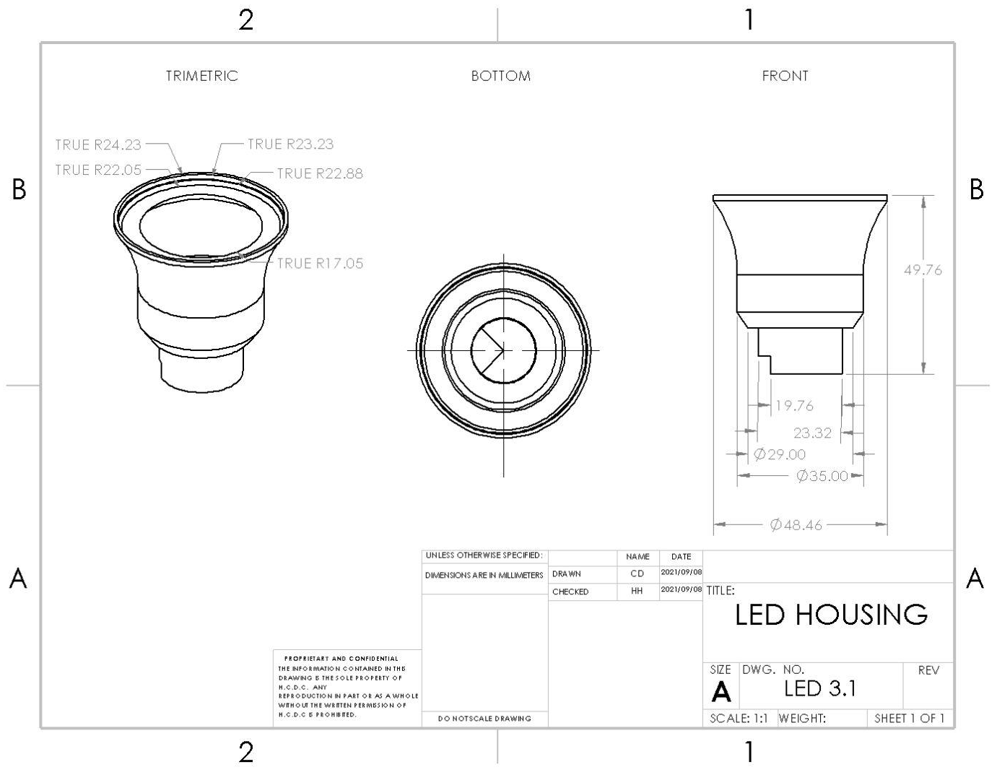[3.1-D]
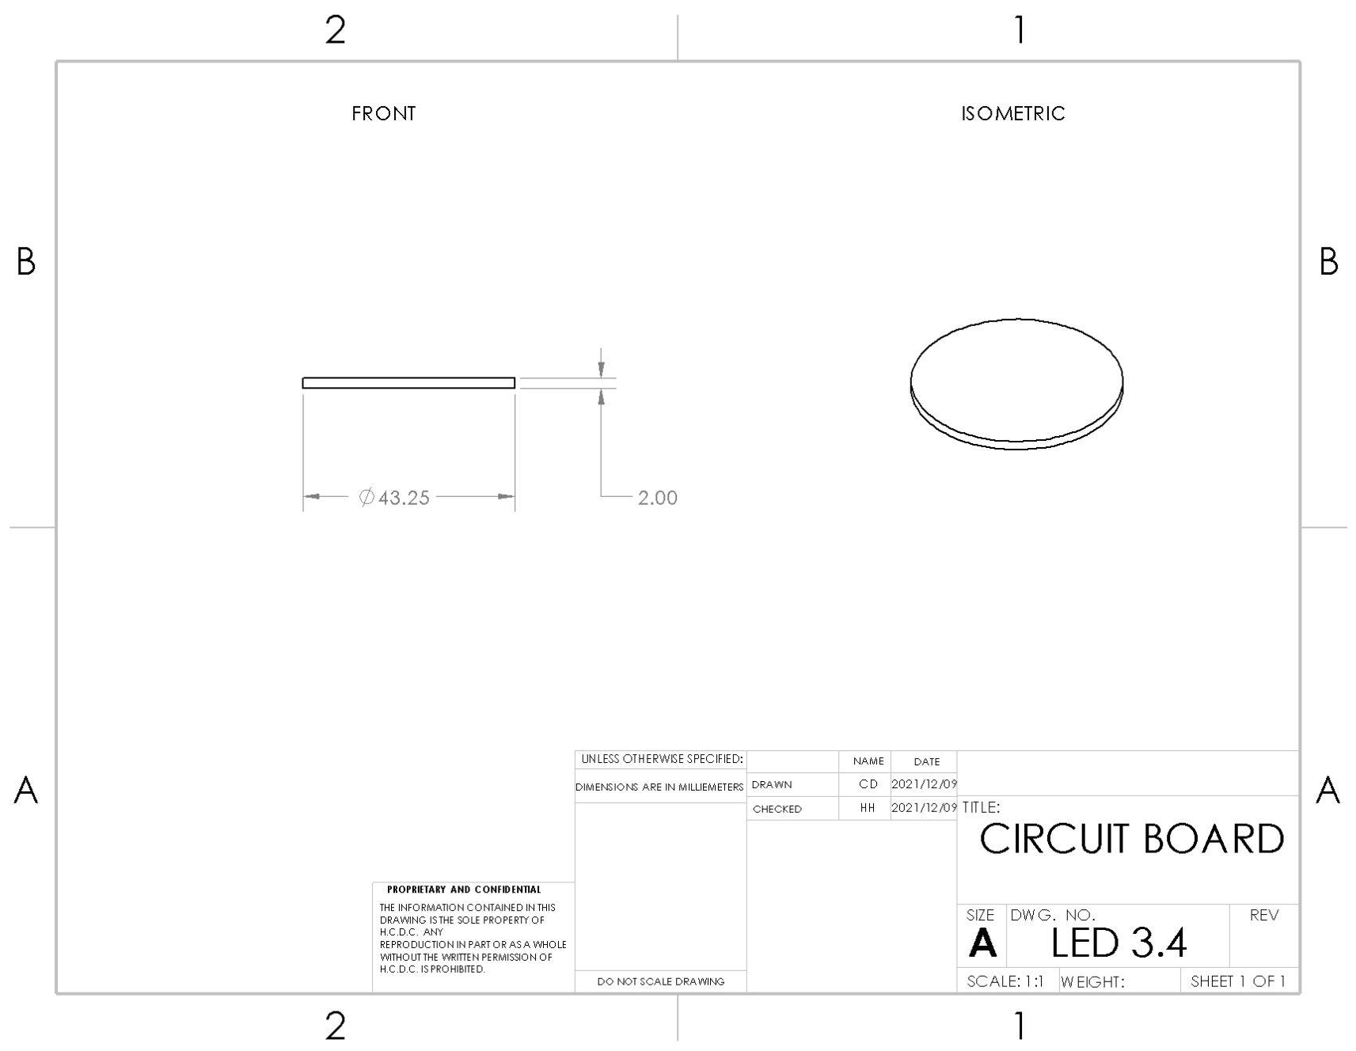[3.4-D]

Prototype 3 3D printed parts:
[3-P] shows the printed full assembly of prototype 3.
[3.1-P] shows the printed housing 3.1.
[3.4-P] shows the printed circuit board.

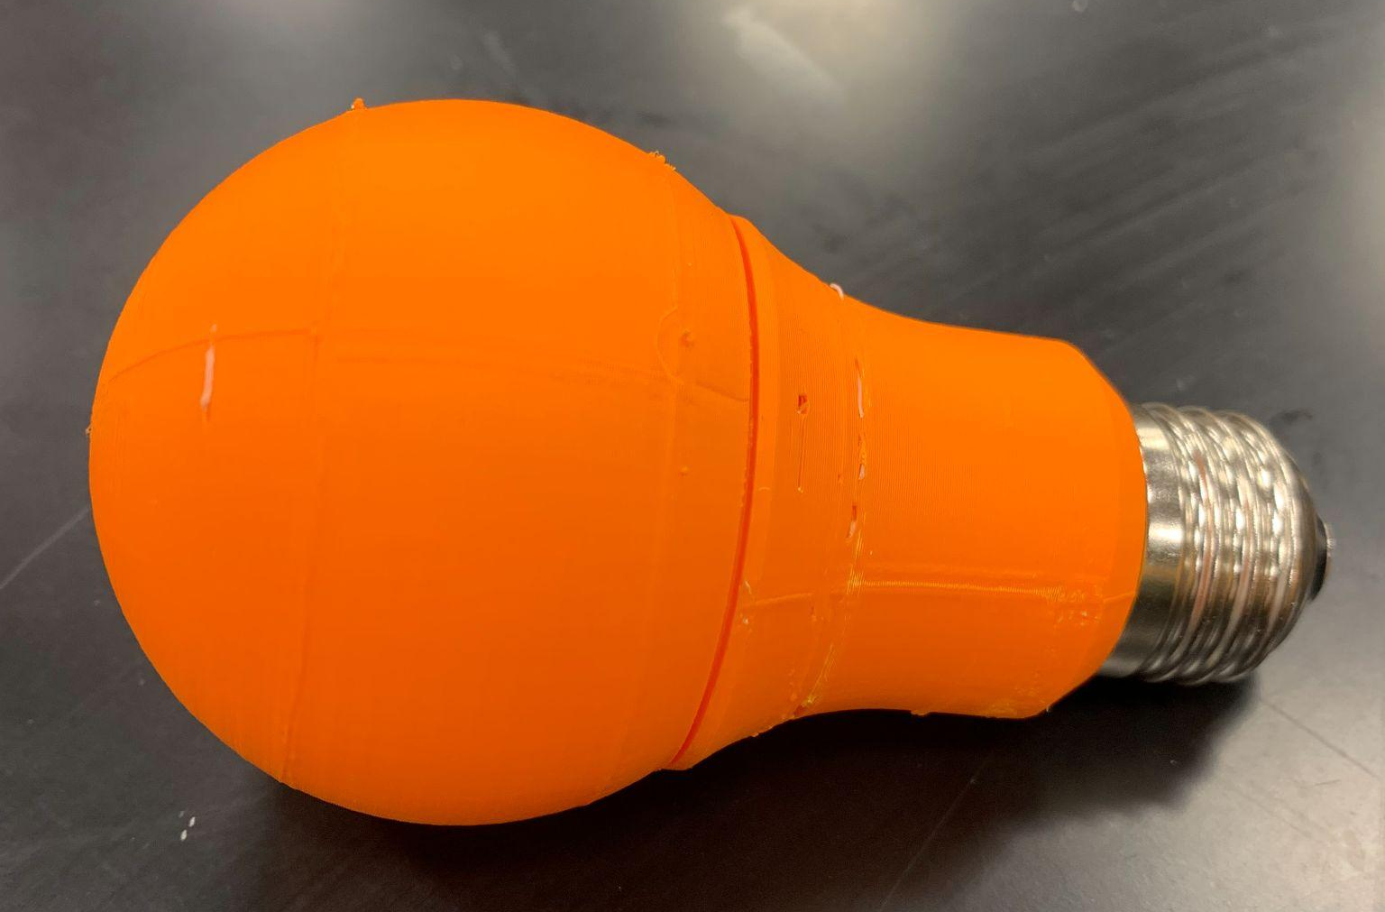[3-P]
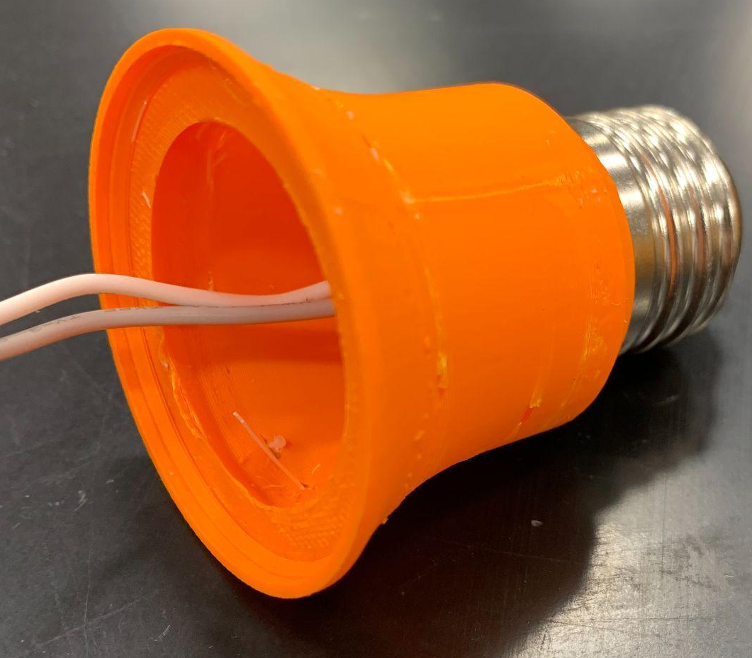[3.1-P]

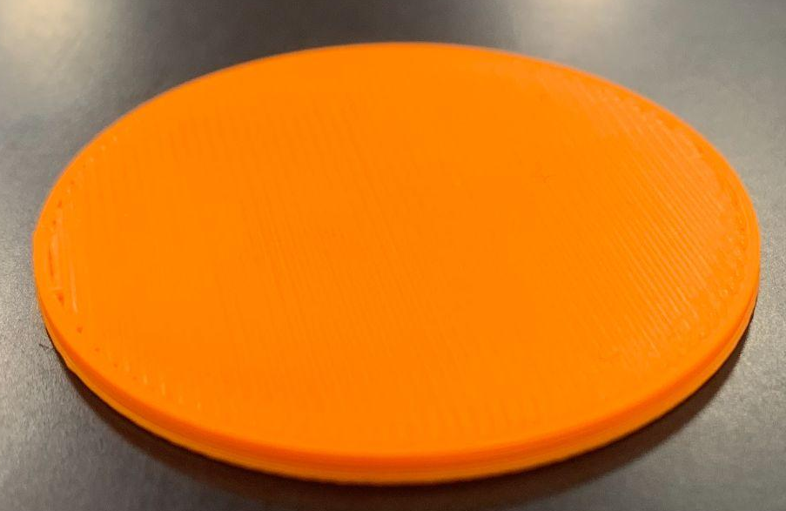[3.4-P]

